Pokhara University

Level: Bachelor | Semester – Fall | Year : 2009
Programme: B.E. |  | Full Marks : 100
Course: Principles of Communication |  | Time : 3hrs.

Candidates are required to give their answers in their own words as far as practicable.
The figures in the margin indicate full marks.

Attempt all the questions.

1. | - How informations are transmitted from source to destination in digital communication system? Explain with the block diagram and point out the function of each block.  - Explain channel capacity theorem. A modem is to be designed for use over a telephone link, for which the available channel bandwidth is 6 khz and average signal to noise ratio on channel is 30 dB. What is the maximum error free date rate that can be supported on this channel and how many signalling state must be used? | 7  8
2. | - State the properties of Fourier series. Determine the Fourier series for the given figure  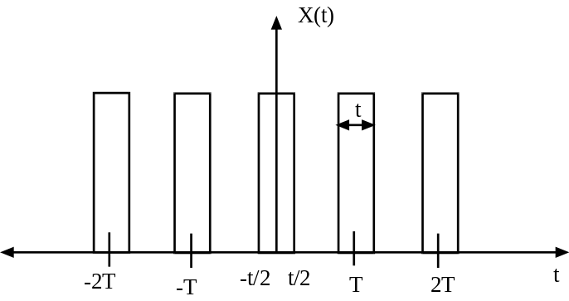  - Explain T1 PCM frame format 5. | 10  5
3. | - What is Intersymbol Interference (ISI)? Explain about the Natural and Flat top sampling with necessary waveform.  - What is quantization noise in PCM? Voice signal band limited to 20 Khz is converted to 8 bit PCM. Find out the bit rate, bandwidth and minimum practical bandwith. | 8  7
4. | - Draw and explain the Superheterodyne Receiver for AM.  - What is limiter explain its types with necessary diagram? Also explain about the condition for distortionless transmission. | 7  8
5. | - What is the purpose of modulation? What are different types of digital modulation techniques? Explain in detail the Amplitude modulation Technique with necessary waveform in case of undermodulation, overmodulation and perfectly modulated condition.  - What is Frequency Division Multiplexing (FDM) Technique? Explain in detail. How does it differ from TDM. | 8  7
6. | - Explain about the cellular telephone system. What are its major advantages? Also explain different generation of mobile communication.  - Explain the working principle of optical fiber. Explain about different types of optical fiber. Point out the major advantages of fiber optic communication. | 8  7
7. | Write short notes on (any two)  - Bandwidth of signal  - Spread Spectrum Technology  - PLL | 5x2

